1.Right-Angled Star Triangle

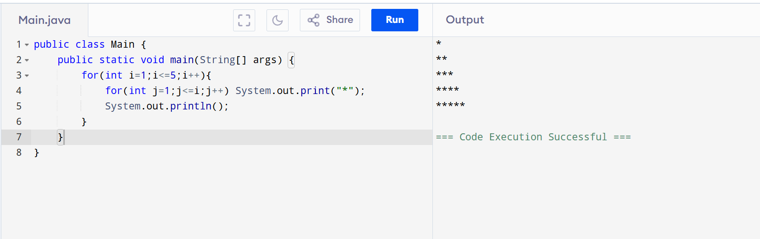
2.Number Pyramid
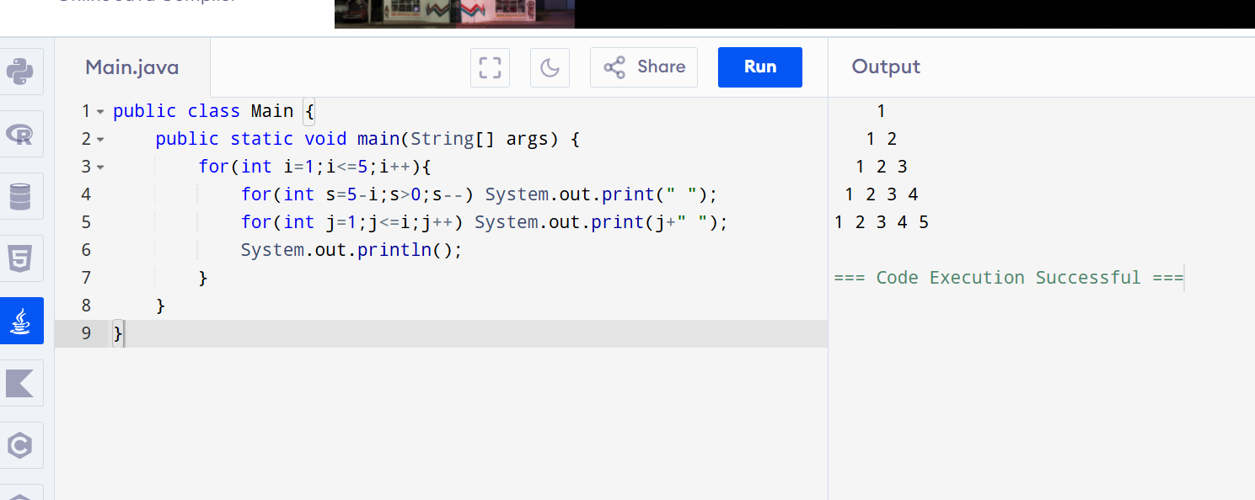

3. Hollow Square
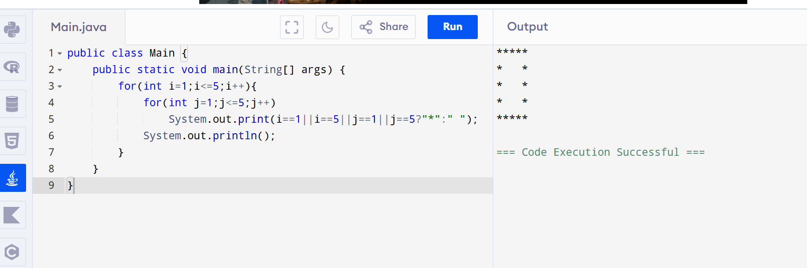

4. Number Triangle
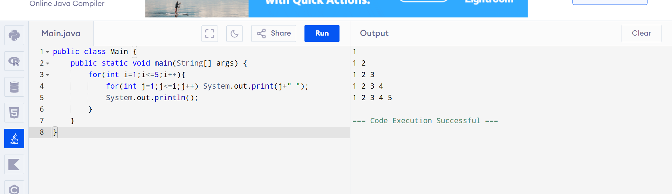
5. Alphabet Triangle
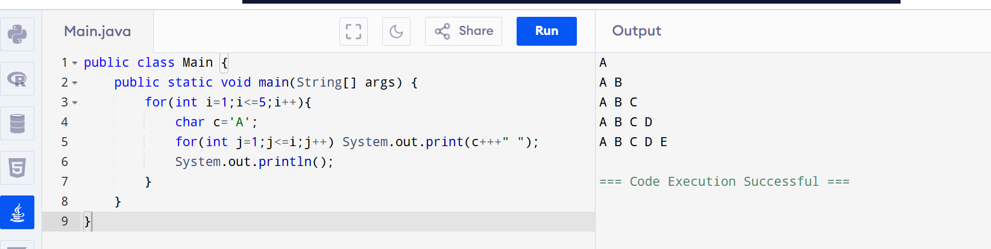

6. Diamond Pattern
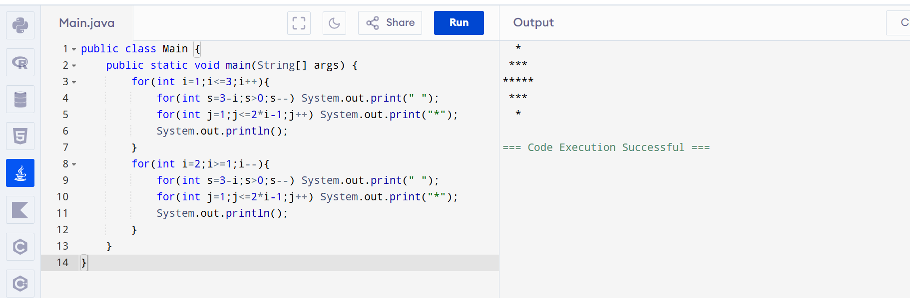

7. Floyd's Triangle
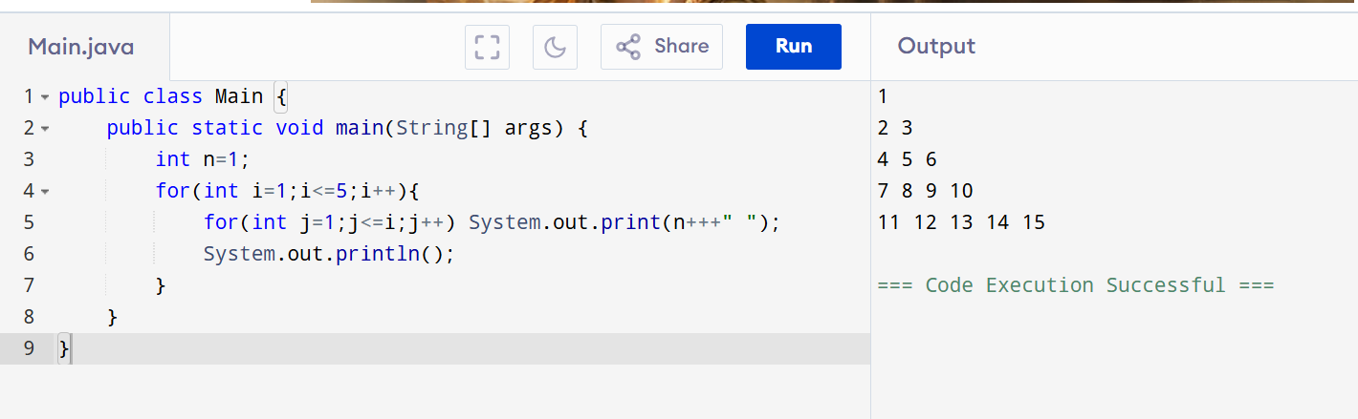
8. Right-Aligned Star Triangle
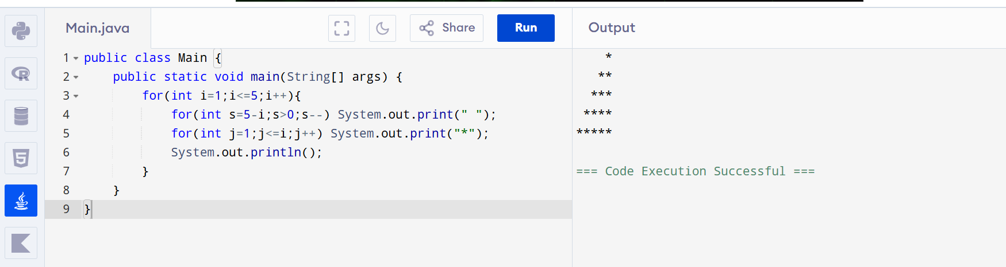
9. Inverted Number Triangle
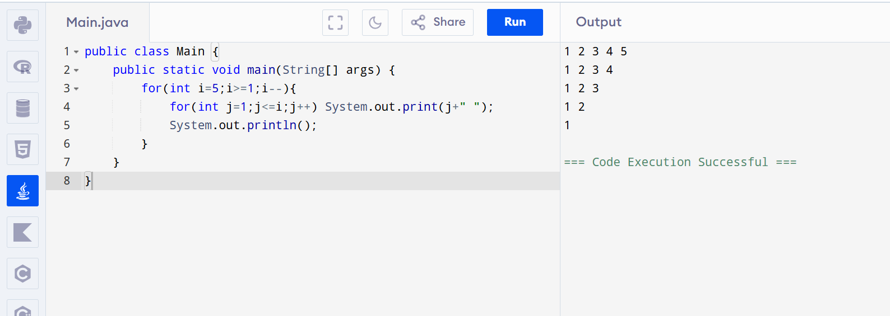

10. Binary Triangle
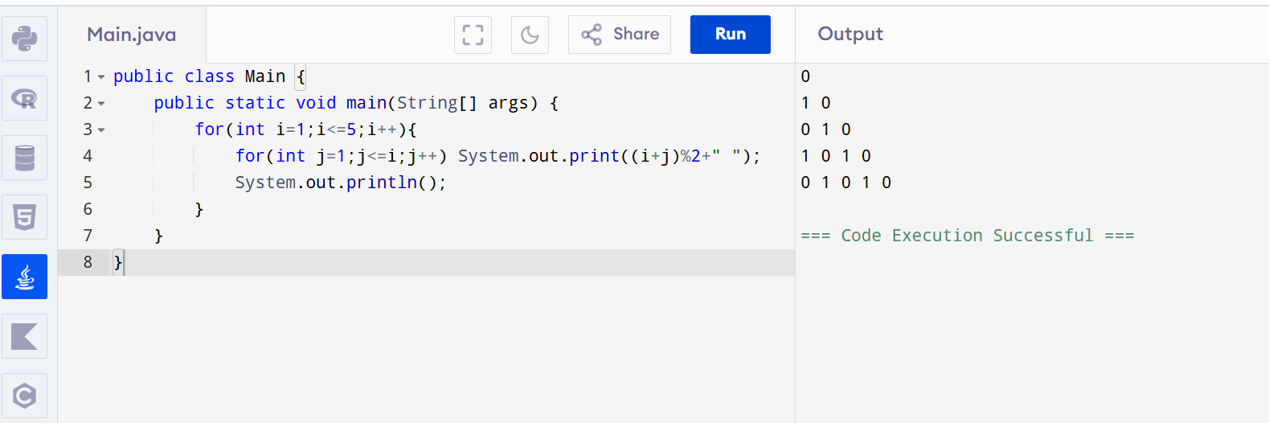
11. Half Diamond
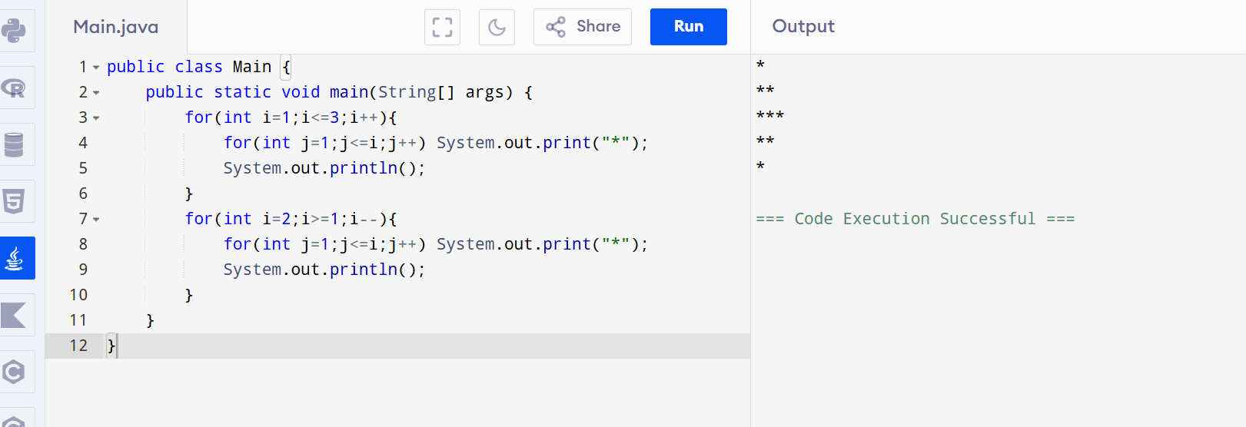
12. Hollow Right Triangle
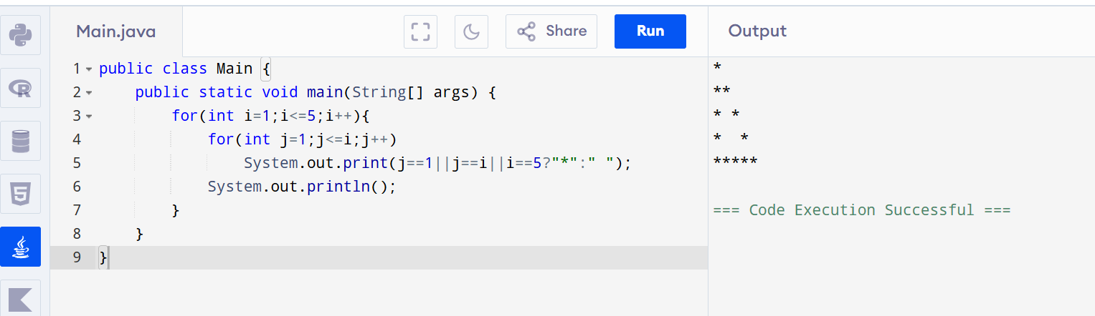

13. Reverse Pyramid
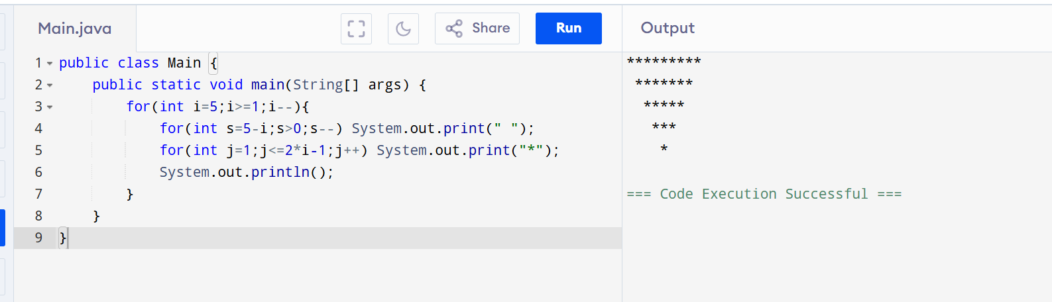
14. Continuous Characters Triangle
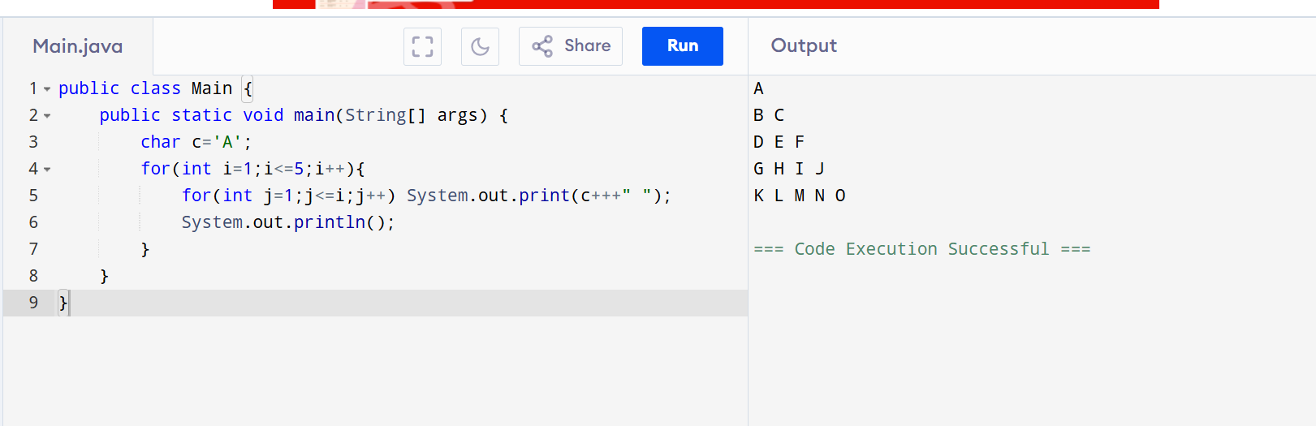
15. Even Number Triangle
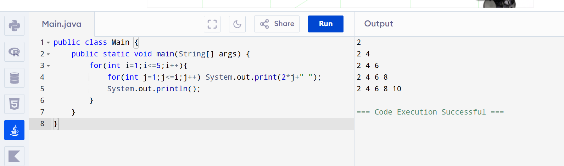

16. Odd Number Triangle
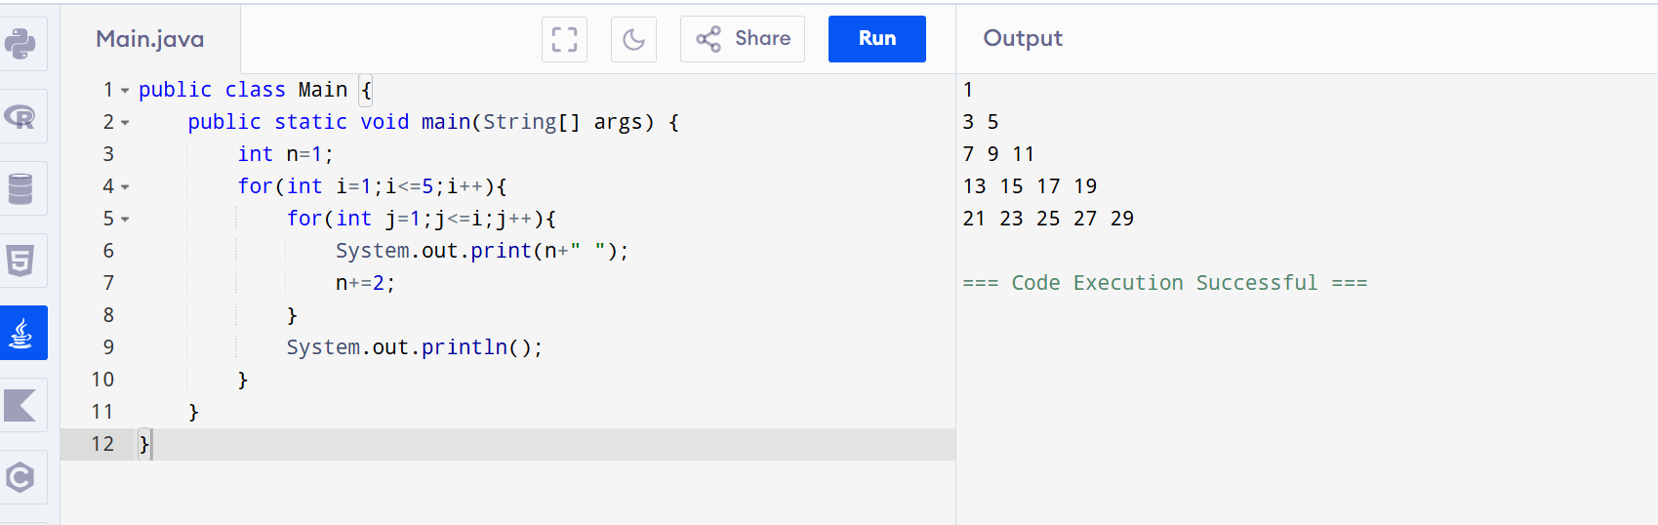
17. Hollow Pyramid
